Module 2

Using the Computer and Managing Files

Module Overview
Welcome to Module 2: Using the Computer and Managing Files.
In this module you will be introduced to Ubuntu Linux Operating System (version 9) with Gnome desktop environment.
 | Upon completion of this module you will be able to:  - Use the main features of the operating system including adjusting main computer settings and using built-in help features.  - Operate effectively around the computer desktop and work effectively in a graphical user environment.  - Understand the main concepts of file management and be able to efficiently organise files and folders so that they are easy to identify and find.  - Use utility software to compress and extract large files and use anti-virus software to protect against computer viruses.  - Demonstrate the ability to use simple text editing and print tools available within the operating system.  - Set up a printer in Ubuntu and use the Print Manager utility to monitor, cancel, pause and resume printing.
Terminology
 | GNOME Desktop | The graphical user interface for the Ubuntu operating system.
 | Operating System | An interface between the computer hardware and the computer user. It is the software program responsible for the management of activities and the sharing of resources of a computer.

 | Ubuntu | Ubuntu is an African word meaning “Humanity to others” or “I am what I am because of who we all are”. It is also a community-developed operating system based on Linux.
 | Window | A rectangular area of the screen that displays an application running on your system.
 | Mounting and Unmounting | The process of adding and removing components to the Linux directory hierarchy.
 | Home directory | When a new user is added to the system, Linux creates a sub-directory of the same name in the home directory. This sub-directory is known as the user’s home directory.
 | Panel | An area in the GNOME Desktop where you have access to certain actions and information such as launching applications, date and time, system sound, volume and more.
 | Securing the system | Shutting down, logging off or locking the system so that other users cannot access your information.
 | File system | A specification for storing and organising files on storage devices such as hard disks.
 | File extension | The part of the file name that follows the final period. File type can be recognised by the extension on the file name.
 | File compression | File compression is a way that a number of files can be compressed into a single file or a single file can be compressed to take up less space on a hard drive or other medium.


Study Tips
You may find it useful to skim through an entire block of content first, paying special attention to the headings and introductions, and then go through a second time for more in-depth study and practice.
However, we recommend that you do the activities as they appear (where you see the 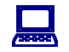icon). They are essential study materials, offering practice in particular skills that will build your proficiency in word processing.
This module forms the basis for subsequent modules in this course. Keep linking the new content that you are studying with content in this module that you have already covered and with your own general knowledge, to deepen your understanding of the operations you are learning.
If you have difficulty understanding any area, try working at it slowly. If you still do not understand, seek help.


Pre-knowledge
Before beginning this module, we recommend that you:
- Study Module 1, because it provides essential background for this module.
- Be comfortable using a keyboard to input text and a mouse to click on objects.

The Ubuntu Operating System

Section overview
Welcome to this section on the Ubuntu Operating System. After studying this section you will:
- be able to start up and shut down your computer safely
- be able to login and logout of your Ubuntu operating system
- become familiar with the features of the GNOME graphical user interface
- be able to customise the GNOME desktop
- secure your system so that the information on your system is safe from others
- use the GNOME help files to get help
- install and remove applications in Ubuntu


Introduction
In Module 1, you learned that the operating system is a set of software that enables the computer to function by controlling hardware devices, allowing network capability and allowing software applications to work with hardware. In this section you will be introduced to one brand of operating system, Ubuntu Linux version 9 – also know as Jaunty Jackalope.
Ubuntu Linux can come in variations with three graphical user interface (GUI) environments: GNOME (Ubuntu), KDE (Kubuntu) or Xfce (Xubuntu). For this module, we will concern ourselves with the GNOME GUI.

First Steps with the Computer

Starting the computer
Most computers have an On/Off switch on the front. Press the On/Off switch on the front of the computer. This will initiate the boot process. During this process the start-up routines that are stored in the ROM of the computer will take control of the computer.
One of the things these routines do is to read certain areas of the hard drive to search for the operating system. The start-up routines will then load the operating system into the RAM of the computer and pass over control to it.
Depending on how the computer has been configured, one of three things will happen:
- The operating system will automatically load the GUI (Graphical user interface) and start this for a default user. The system will be available for immediate use.
- The operating system will automatically load the GUI, but you will be prompted to enter a username and password. These will be given to you by whoever installed the system.
- Only the text based operating system will load. In this case you will need to logon and then start the GUI. In this case you will see a black screen on which the prompt Logon: appears.

Logon to Ubuntu
After Ubuntu has gone through its boot procedures, either the GUI will load or you will be prompted to input your username and password. If you need to use username and password to access your system, remember that passwords are case sensitive. If you are given a password, you must enter it exactly as given.
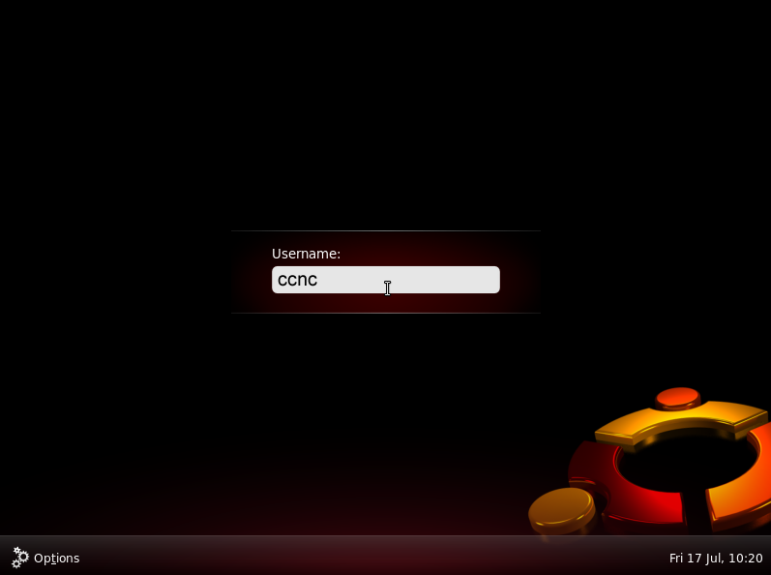
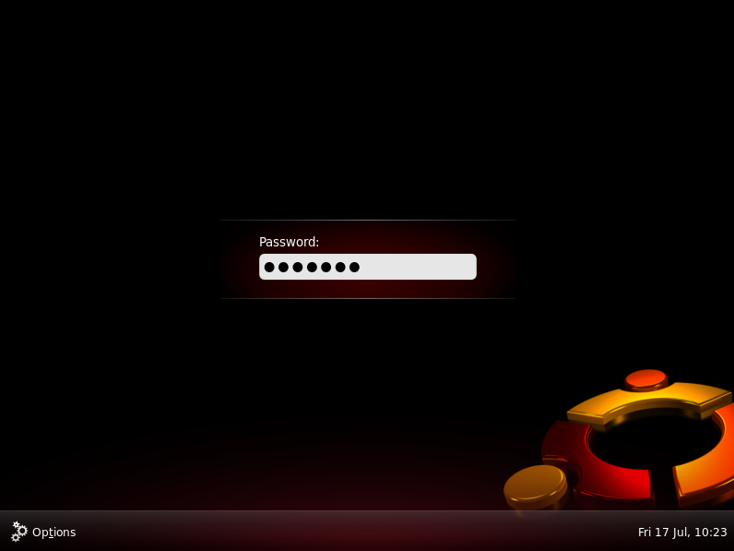
When you have successfully entered your username and password, the GNOME desktop will load.

The GNOME Graphical User Interface
GNOME provides you with a graphical view that makes it easier to perform tasks either using the keyboard or with the click of a mouse.
The image below illustrates the main features of the GNOME graphical user interface.
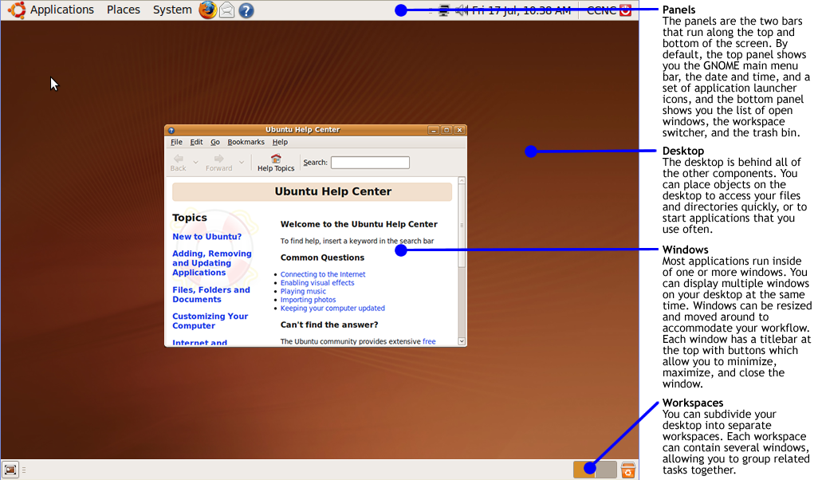

Windows
A window is a rectangular area of the screen that displays an application running on your system. Windows usually have a border all around and a title bar at the top.
You can think of a window as a screen within the screen or as pieces of paper on your desktop. You can have many windows open at once, allowing you to have more than one application visible and work on more than one task at a time.
Windows can overlap or be side by side. You can control a window’s position of the screen, as well as its size. You can control which windows overlap other windows, so the one you want to work with is completely visible.
Below is an example of a window containing the Ubuntu Help Center application.
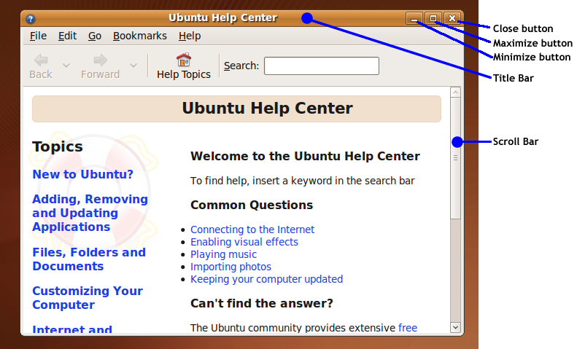

Working with Windows
Move the window
Drag the title bar to move the window. You can click on any part of the title bar except the buttons at either end to begin the drag action. The window will move on the screen as you drag the mouse.
Resize the window
Drag one of the borders to expand or contract the window on that side. Drag a corner to change two sides at once. The resize pointer appears when your mouse is in the correct position to begin the drag action.
Minimise the window
Click on the Minimise button in the title bar, the leftmost of the group of three on the right. This removes the window from view.

Maximise the window
Click on the Maximise button in the title bar, the middle of the group of three on the right. This expands the window so it fills the screen (the panels remain visible).
Unmaximise the window
When a window is maximised, click again on the Maximise button to restore it to its previous position and size on the screen.
Close the window
Click the Close button, the rightmost of the group of three on the right. Closing the window may also close the application itself.
Scrolling
If the application that is open is too large for the window, you will see scroll bars either on the right, bottom or both. Drag the scroll bar or click on the arrows at either end of the scrollbar to scroll through the windows contents.

Panels
A panel is an area in the GNOME Desktop where you have access to certain actions and information. For example, you can launch applications, see the date and time, control the system sound volume and more.
By default, the GNOME Desktop contains a panel at the top edge of the screen and a panel at the bottom edge of the screen. You can customise panels to your liking. You can change their behaviour and appearance and you can add or remove objects from your panels. You can create multiple panels and choose different properties, objects and backgrounds for each panel. You can also hide panels.
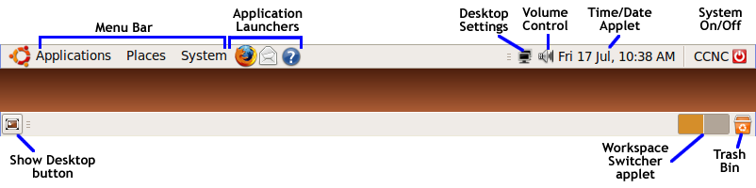

Working with Panels
Move a panel
Drag a panel to another side of the screen to move it there. Click on any vacant space on the panel to begin the drag.

Panel properties
Right-click on a vacant space on a panel, then choose Properties from the context menu. You can set the following panel properties:
- Orientation: Select the position of the panel on your screen. Click on the required position for the panel.
- Size: Use the spin box to specify the size of the panel.
- Expand: By default, a panel expands to the full length of the edge of the screen where it is located. A panel that does not expand can be moved away from the screen edges to any part of the screen.
- Autohide: Select this option if you want the panel to only be fully visible when the mouse pointer is over it. The panel hides off-screen along its longest edge, leaving a narrow part visible along the edge of the desktop. Move the mouse pointer over the visible part of the panel to make it move back into view.
- Show hide buttons: Select this option to display hide buttons at each end of your panel. Clicking on a hide button moves the panel lengthways, hiding it off-screen except for the hide button at the opposite end. Click this hide button to restore the panel to being fully visible.
- Arrows on hide buttons: Select this option to display arrows on the hide buttons, if the hide button is enabled.
- Background: Click on the Background tab to set the background colour or image for the panel.

Adding and Deleting Panels
To add a panel, right-click on a vacant space on any panel, then choose New Panel. The new panel is added to the GNOME Desktop. The new panel contains no objects, but you can customise it to suit your preferences.
To delete a panel right-click on the panel that you want to delete, then choose Delete This Panel.
Note: You must always have at least one panel in the GNOME Desktop. If you have only one panel in the GNOME Desktop, you cannot delete that panel.

Users Guide
For a detailed GNOME User’s Guide, you can go to the GNOME site at http://library.gnome.org/users/user-guide/stable/index.html.en.

Securing your system

Locking, Logging Off and Restarting the Computer
When you are finished your Ubuntu session, it’s a good practice to either lock, log off or shutdown your computer. The main reason for this has to do with security – if your computer is left unattended with you logged in, others could then use the computer and impersonate you.
- Click on the icon on the top-right part of your desktop. This will open a dialogue window with options for locking, logging off, restarting or shutting down your computer.
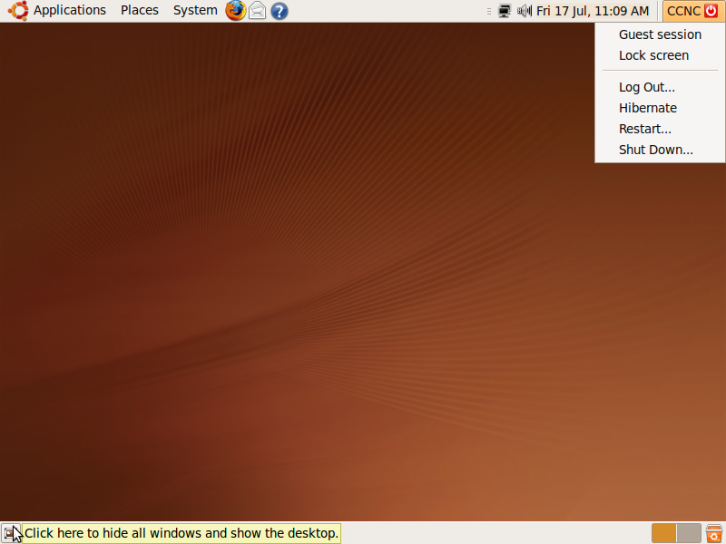

- Click on the option you want. The options are:
  - Guest session: this option effectively locks the screen for the current user, but creates a “guest” session so that someone else can use the computer, but without access to your settings or files.
  - Lock screen: this option locks the screen so that nobody can use the computer until you unlock the screen with your password.
  - Log out: this logs you out of the system. For someone to use the computer, they must first log in.
  - Hibernate: this option puts the computer in a “sleep” mode.
  - Restart: shuts down the computer and then restarts it.
  - Shut Down: shuts down the computer and turns the power off.


Tip: Never just shutdown the computer by pressing the On/Off switch. This can do damage to your operating system or hardware and could result in the loss of data. Always shut down from the Ubuntu menu.

Shut down a non-responding application
It may happen that an application freezes and will not respond to mouse clicks or keyboard commands. You can close the application without restarting your system by using System Monitor.
- From the Ubuntu System menu, click on Administration, then on System Monitor.
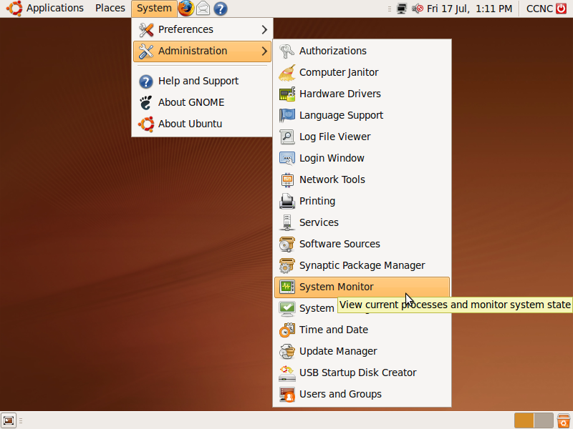
- When System Monitor loads, click on the Processes tab to view all of the processes running on the system.
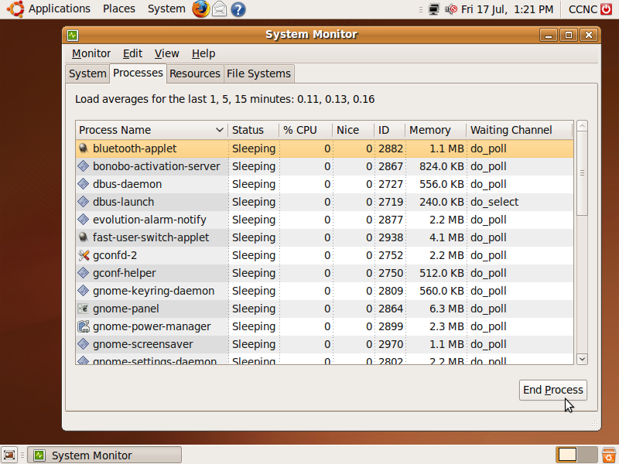
- Click on the non-responding process and then click the End Process button to shut down the application.
- When done, quit System Monitor by clicking on the Close icon in the top right of the screen.

What to do if the entire system freezes
If the entire system freezes, do not immediately switch of the system with the power switch. This could cause serious damage to the entire system. This is only a final resort.
The most likely cause of a frozen system lies with the GUI.
- Wait a while. The system may wake up on its own.
- If the system doesn’t respond after a few minutes, press these keys on your keyboard at the same time: Ctrl + Alt + Backspace.
This will cause you to lose all unsaved work, but it will preserve the system itself.

Getting Help
The help systems in Ubuntu are searchable databases of information about the operating system and applications you will be using. Along with help information on the Internet, they are a very good starting point for when you have questions or problems with your system.

The Ubuntu Help Center
To access the Ubuntu Help Center, click on the Help icon on the top of your screen.
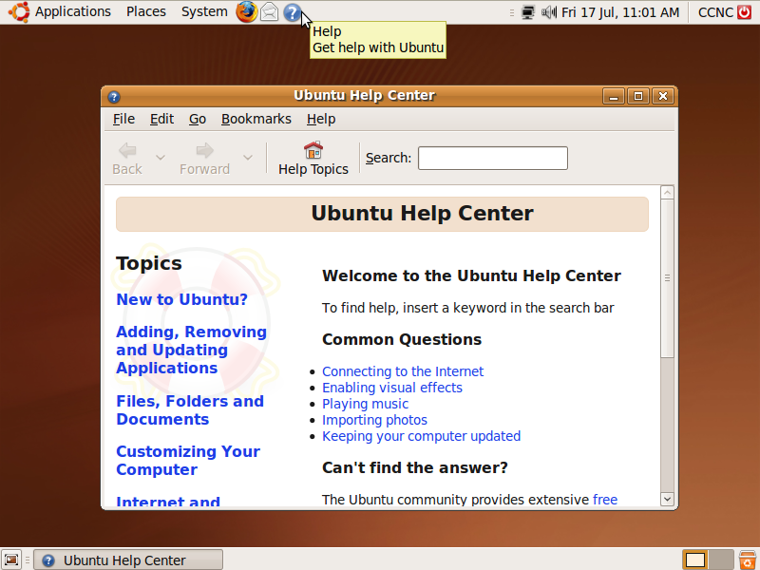
You can either browse the help files by clicking on the links in the Help window or you can search for help on a specific topic.

Context Help
You can access help files on any application you are using by clicking on the Help menu from within the application. For example, if you want to get help with using the System Monitor, click on Help from within System Monitor and the click on Contents.
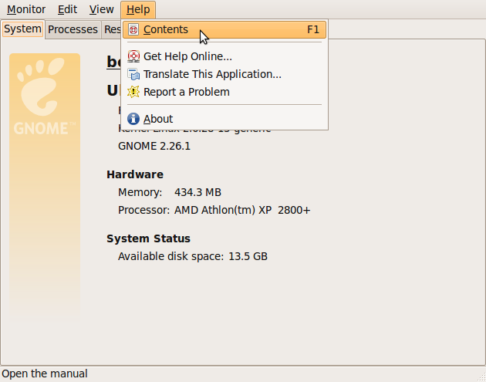

Using Help as a Tutorial
Become as familiar as possible with the help system. These notes will provide you with an introduction to Linux using the GNOME desktop. When you have worked through a section in these notes, you could read what the GNOME help system has to say on the topic. If you wish to become an expert, you will need to read further and discover the full power of Linux. The help system is the best place to start.

Basic Information and Operations

The System Monitor
The System Monitor displays basic system information and monitors system processes and resources. As you have already seen in the previous section, you can also use System Monitor to change how your system behaves, such as closing non-responding programs.

To start System Monitor:
- From the Ubuntu System menu, click on Administration, then on System Monitor.
To close System Monitor:
- Click on the Close icon in the top right corner of the application.

Viewing System Information
The System tab in System Monitor will show you the following information about your system:
- distribution version (the version of the operating system you have installed)
- hardware: RAM, processor type and processor speed
- system status: available disk space

Viewing Active Processes
You have seen in the previous section that you can click on the Processes tab in System Monitor to view and, if needed, stop processes that are running on your system.

Viewing Resource Use
Clicking on the Resources tab shows you a display of your system’s CPU usage, memory usage and network activity as it is being monitored.

View the File Systems
The File Systems tab shows you what file systems are in use and how much disk space is being used and how much is available.

Desktop Configuration
In this section you will learn how to adjust your operating system settings to customise your GNOME desktop. You can access most system preference settings from the System menu by clicking on System and then Preferences:
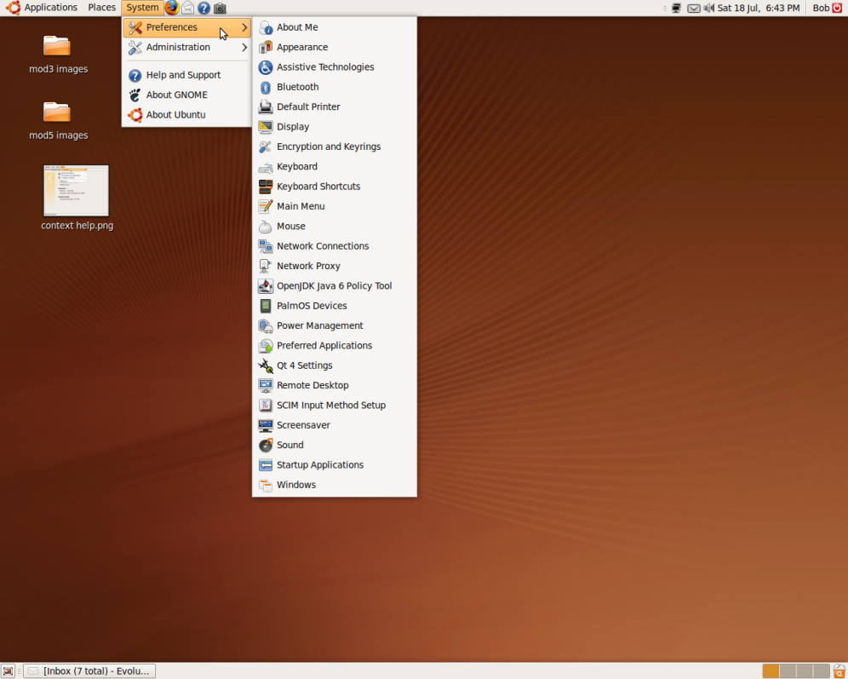
or by clicking on System and then Administration:
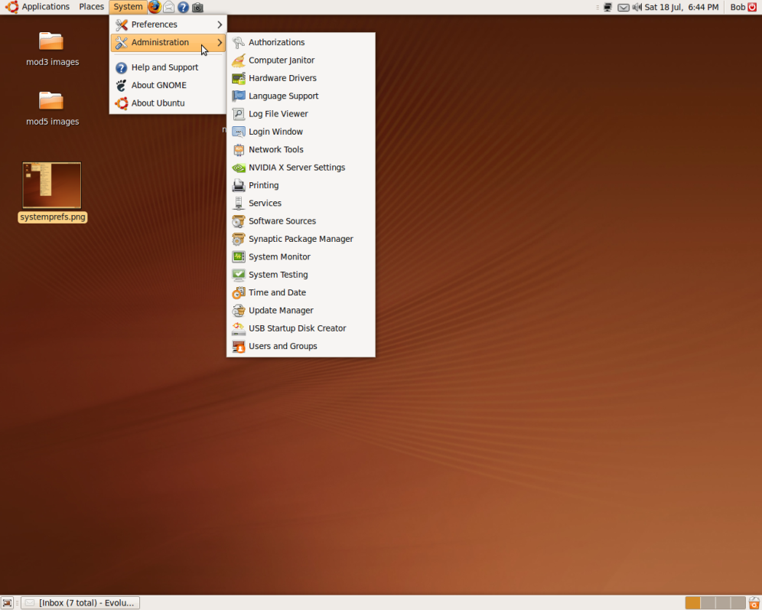
Other settings can be accessed directly from the system window.

Set the Date and Time
- From the System-Administration menu, click on Time and Date.
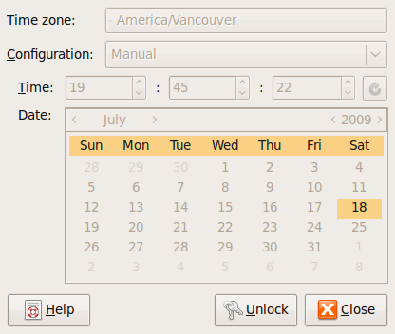
- Click on Unlock to unlock the settings window and enter your system password when prompted.
- Adjust the time zone, date and time on the calendar and clock.
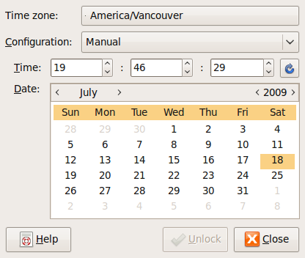

- Click Close when done.

Set the volume level
- To access your sound settings, click on the Volume icon at the top of your system workspace.
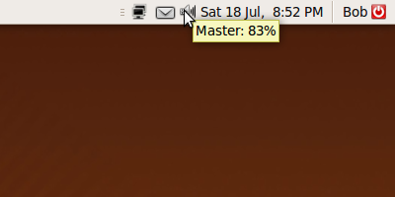
- Slide the volume control slider to the left or right to set the volume on your system.
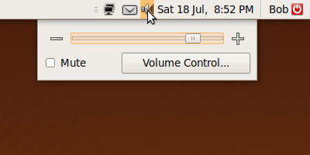

Change the desktop appearance
- From the System menu click on Preferences and select Appearance.
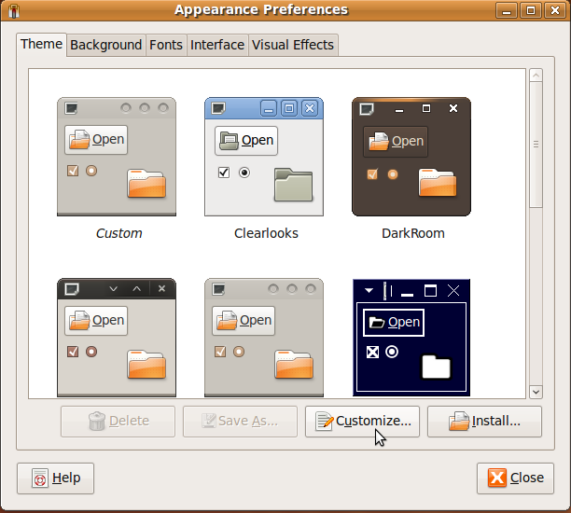

- Click on the Theme tab to set a desktop theme. A theme is a group of coordinated settings that specify the visual appearance of the desktop.
- Click on the Background tab to set the desktop background. You can either set a background colour or use a picture for the background.
- Click on the Fonts tab to specify the fonts that are used in the desktop.
- Click on the Interface tab to customise the appearance of menus, menu bars and tool bars.
- Click on the visual effects tab to enable or disable a group of visual effects intended to make your desktop easier to use.

Change screensaver
A screensaver is a visual effect that occurs on your screen when your computer has been idle for a certain amount of time. Screensavers were designed to be visually interesting and to provide some motion on the screen since some older computer monitors are susceptible to damage if the same image is left on the screen for a long period of time.

- To access screensaver settings, from the System-Preferences menu click on Screensaver.
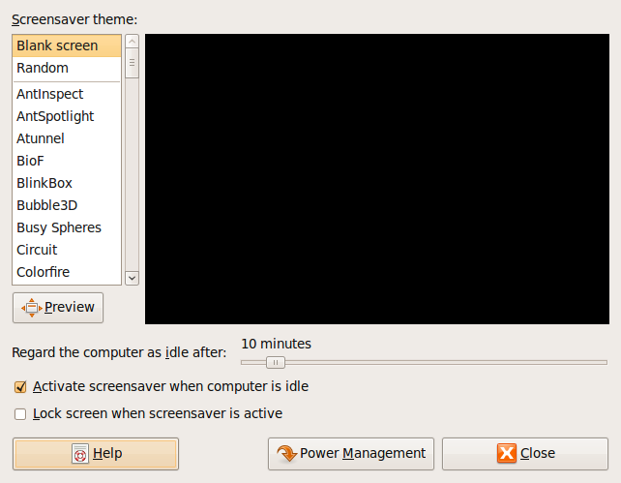

- Choose a screensaver theme from the list on the left of the window.
- Set the length of time for the computer to be idle before the screensaver is activated.
- Make sure the box is checked beside Activate screensaver when computer is idle. Uncheck this box to disable the screensaver.
- If you like, you can have the screensaver lock the screen when it activates. This means that for someone to use the computer they will have to input their password.

Set screen pixel resolution
Note: This setting is not standard for all computers; it depends on the display card being used. You should refer to your video card documentation to set the screen resolution.

Set keyboard language
The keyboard language defines the position of the various keys on the keyboard. For example, British, American and French keyboards all have different layouts. If some of the keys generate a different letter to that shown on the key itself, it could be that the keyboard language setting needs to be changed.
- Click on System>Preferences>Keyboard
- When the Keyboard dialogue window opens, click on the Layouts tab.
- Click on the Add button to add a keyboard layout.
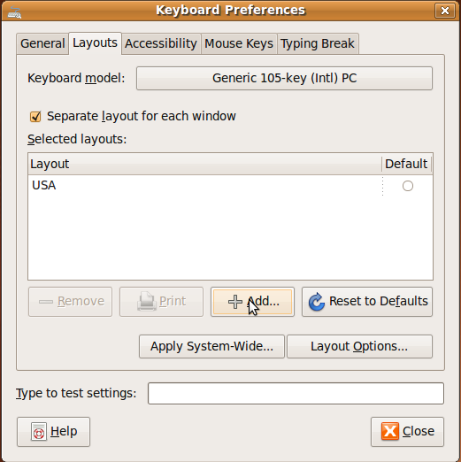
- Click on the By language tab to choose your new keyboard layout by language.
- Choose a new keyboard layout from the Language list and Variants list and then click the Add button.
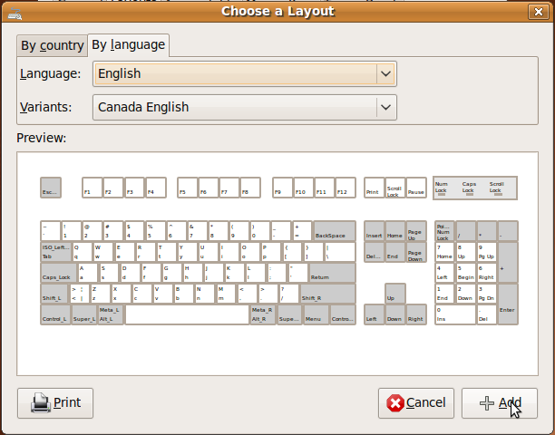

- Click on the Default radio button to make this your default keyboard layout and then click Close.
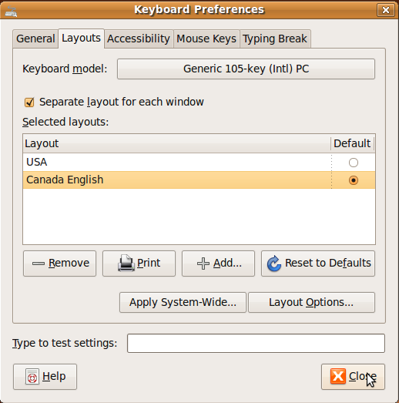

Formatting Discs
Formatting a disk, device or partition means to prepare that device for storing data. When you format a device, you apply a specific data-storage format to that device. It’s important to keep in mind that the format you apply may not be read or written to by all operating systems. For example, you can’t format a hard disk for a Macintosh system and have the disk read by a Microsoft Windows system.

File systems
A file system is a specification for storing and organising files on storage devices such as hard disks. A file system is absolutely necessary for your operating system to be able to store and access files. Common file systems are:
- ext2 and ext3: These are Linux files systems. Ubuntu uses ext3 as its default file system.
- FAT16 and FAT32: These are older Windows file systems. If you need to format a disk that is going to be used on a number of different operating systems, FAT32 is a good choice because it can be read and written to by Linux, Macintosh OSX and newer versions of Microsoft Windows.
- NTFS: This is the file system for newer versions of Microsoft Windows.
- HFS+: This is the Macintosh OSX default file system.
You can access disks on your system from the GNOME menu by clicking on System>Administration>Partition Editor.
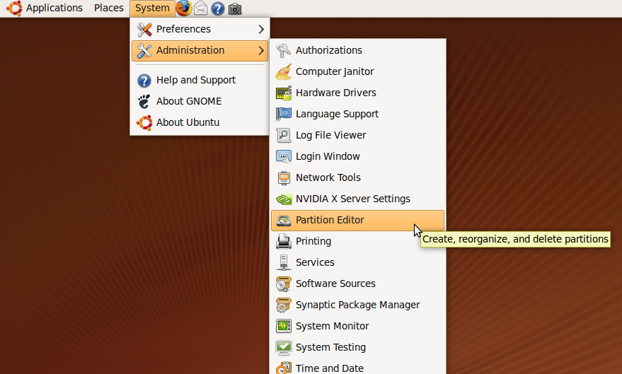
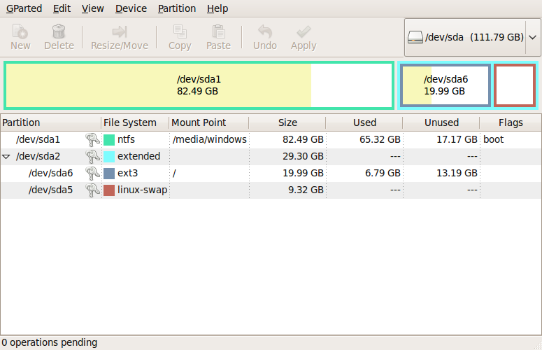

Installing and Uninstalling Applications

Install applications from distribution CDs
Ubuntu Linux maintains a database of applications and their locations. Initially these are applications that are stored on the distribution CDs. Depending on the particular installation, only certain of these may be installed on a given system. The following illustrates how to install OpenOffice from the Ubuntu distribution CDs.
- System>Administration>Synaptic Package Manager.
- Enter the root password when prompted.
- Click All.
- Click on OpenOffice to expand its contents.
- Click on Mark for installation. A window appears warning you of dependencies. A dependency refers to other software which needs to be installed on the machine before the application can be installed.
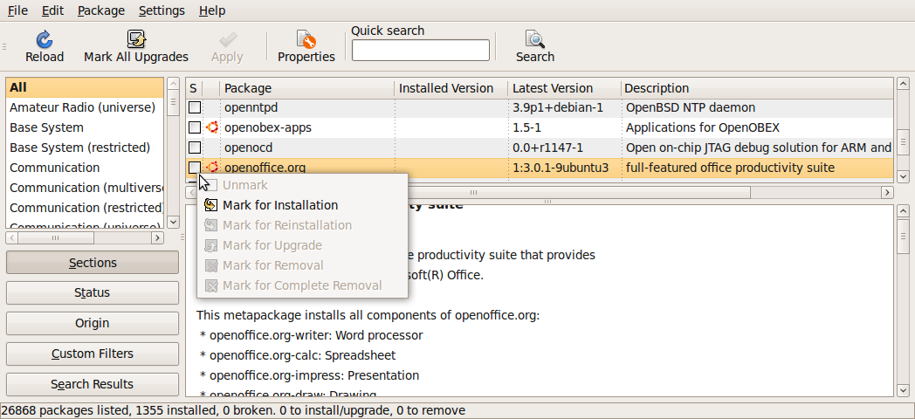

- Click Apply.
- When prompted, insert the required CD and click OK.
- Other prompts may appear. Respond by clicking OK if you wish to proceed with the installation.
- Verify that the application has been installed.
Open Office can also be downloaded from http://www.openoffice.org

Install applications from a CD with an install program
You may get an application as part of a CD or through a download across the Internet. In some cases these applications are distributed with an install file. Double clicking on this in a file manager will initiate an automated installation process. You then simply sit back and wait for the entire process to complete.

Install an application using the File Manager
The following illustration assumes the application is located on a CD.
- Double click on the CD-ROM icon on the desktop.
- Locate the directory in which the application installation file is located.(This process will be explained fully in the next section on file management)
- Double click on the application.

Uninstall an application
The following example illustrates how to uninstall an application
- Start Applications>System>Synaptic Package Manager.
- Enter the root password when prompted.
- Select the software you want to remove.
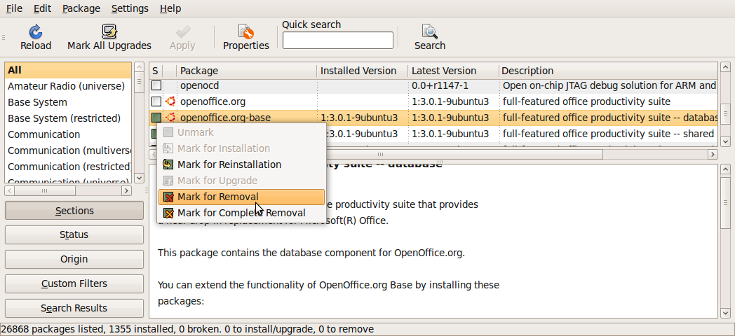

- Select Mark for Removal.
- Click Apply.


Summary
In this section, you learned:
- How to start up and shut down your computer safely and how to login and logout of the Ubuntu operating system.
- About the main features of the GNOME graphical user interface.
- How to customise GNOME to suit your personal preferences.
- How to secure your system so that your information is safe from other users.
- How to install and remove applications in Ubuntu.
- How to access help files in Ubuntu.

File Management

Section overview
Welcome to this section on File Management. After studying this section you will:
- understand the concept of directories and files as they apply to the Linux operating system
- be able to use the Nautilus File Browser to navigate through directories
- be able to change the view options for directories
- create, rename, move, copy and delete directories
- change permissions for directories
- understand how files are named and what filename extensions are
- be able to sort files by name, size and date modified
- create, rename, move, copy and delete files
- understand the importance of backing up data
- restore files from the trash bin
- empty the trash bin
- search for files and directories
- use a file compression utility

Concepts
To understand the concept of a directory, consider an analogy of an office block containing a number of offices. Each office has a name. Inside each office there are a number of filing cabinets, each of which is named. Files are stored in the filing cabinets. Each file also has a name.
Suppose a file called Lombard is located in the Staff cabinet of the Administration office. This could be described in a shorthand form as:
/Administration/Staff/Lombard
In the same way /Stores/Suppliers/Kumar would indicate a file called Kumar in the Suppliers filing cabinet in the Stores office.
Directories on a computer system are similar to the offices and filing cabinets. A directory is a container that can contain files or other directories. A directory located inside another directory is called a sub-directory. Sometimes the word folder is used in place of the word directory. One difference between the analogy and a computer system is that in the former case we are dealing with physical objects whereas in the latter we are dealing with a more abstract structure.
Directories, sub-directories and files are arranged in a hierarchical structure called a tree. A typical computer will contain many thousands of files stored in many directories. Each directory contains files that are related in some way. The starting point of the tree is called the root. Do not confuse this usage of the word with the special user that has complete control over the system. Root is designated by the / symbol. This symbol is also used to separate the different levels of the hierarchy.
A directory structure may contain many levels of sub-directories. The following diagram illustrates part of a Linux system directory structure.
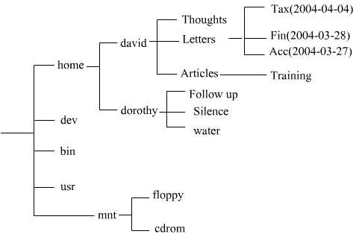
The full description of the location of a file is called is path. If we wish to describe a file fully, we need to include its path. An example from the previous diagram would be: /home/david/Letters/Tax(2004-04-04).
Linux names are case sensitive. Hence the three names tax, Tax and TAX are all different as far as Linux is concerned. Using the wrong case for letters is a common source of errors.
If you have worked with Windows, the Linux directory structure may seem confusing at first. Each system has a single directory system. Drives are located within branches of the structure rather than the structure starting with a drive. Linux goes much further and includes devices such as ports and printers within the directory structure. This follows from the fact that Linux treats files and devices in the same way.
The process of adding components to the Linux directory hierarchy is called mounting and removing them is called unmounting.
The home directory is of special importance in Linux. When a new user is added to the system, Linux creates a sub-directory of the same name in home. For example, if the user dorothy is added, Linux will create the directory /home/dorothy at the same time. This sub-directory is known as the user’s home directory. Each user will create a further series of sub-directories in which he/she will store files.
Each user’s home directory is private to that user. Apart from the owner of the home directory, the only other user that normally has access to it is the root user.
Each user can access his/her home directory by clicking on the System Menu then Home.

Storage Devices
You already know that the devices used by an operating system to store files and folders are the hard disk, diskette, CD-ROM, network drives.
For long term storage, files are stored on various secondary memory devices. These include hard disks, floppy disks, CD-ROMs, DVDs, Zip disks, tape and flash memory. These devices were described in Module 1.
Although we can think of directories as containers for files and sub-directories, these are logical structures rather than physical areas on a disk. The actual method of physically storing files on disk and organising them in directories is a very technical topic. From a user’s perspective, the important thing is to understand directories as providing a logical method of grouping related files together in one place.
Where computers are connected together through a network, each user will see the disk drives on other computers as part of his/her own directory tree. In fact, if the user has not set up the system, he/she will not necessarily even be aware of the physical location of different parts of the directory tree.
One of the strengths of Linux is that it fully integrates a network into a single system.

Directories/Folders

Nautilus File Browser
Ubuntu has a built-in application called Nautilus for navigating through the file system on your computer and for managing your computer’s desktop. Nautilus is always running while you are using GNOME. To open a new Nautilus window, choose an item from Places menu on the top panel.

The Home Folder
Whenever a new user is created in Ubuntu, a folder, called the Home Folder, is also created for that user. You can access your Home Folder by clicking on the Places menu and choosing Home Folder.

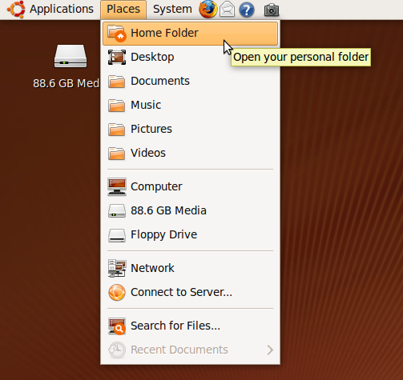
The Home Folder contains a number of default folders to hold documents for each user. These folders are:
- Desktop: this folder contains all of the objects that will appear on your desktop, such as files, folders and shortcuts to places or applications.
- Documents: A folder to store documents such as word processor files, spreadsheets or databases.
- Music: a folder to store your music files.
- Pictures: a folder to hold graphics and photographs.
- Public: a folder that you can use to share files with other users.
- Templates: used to store documents that will be used as a template to create new documents in OpenOffice or other applications.
- Videos: a folder used to store video files.

Alternate views
You can change how Nautilus displays directories and files by changing the view from the folder menu. You can choose to view the folder contents as icons, as a list or in “Compact View” which has small icons with the file names.

Icon View
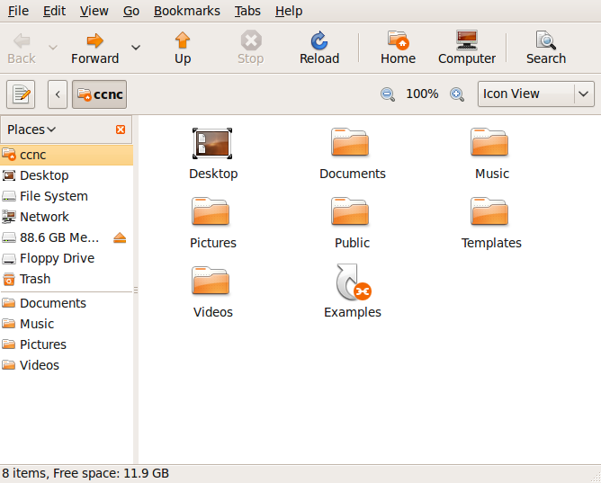
Compact View
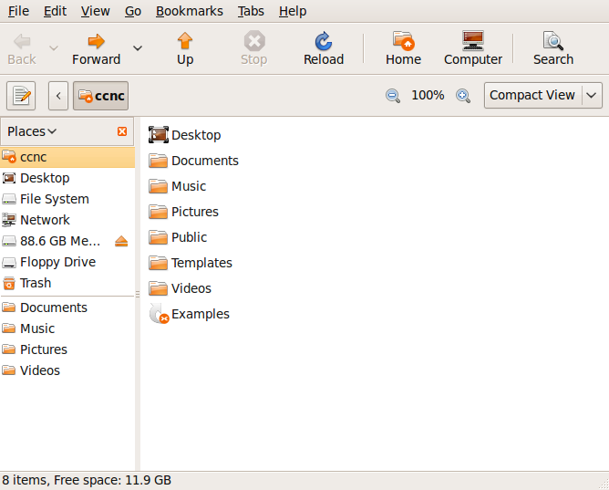

List View
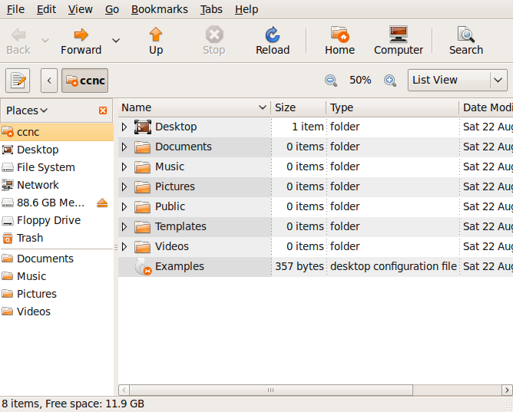
Note: Viewing directories in List View also displays the size of the file or the number of files or sub-directories within a directory, the type of file and the date the file or folder was last modified.

Navigating through directories
There are many ways to navigate through folders. As you use Ubuntu, you will find the navigation style that suits you best.
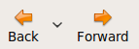 | The Back and Forward icons allow you to trace your steps back and forward through the directories you have visited during your current session.
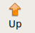 | To navigate up one level in the directory structure, click on the Up button.
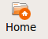 | To return to the home directory at any stage, press the Home icon.
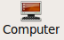 | To view all of the storage devices on your computer, click on the Computer icon.
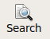 | To search for a file or directory, click on the Search button and type the file name or directory name in the search bar.
You can also move to a new directory, by double clicking on a directory icon in the main pane or choosing a directory from the list of Places in the left pane.
Finally, you can also type the name of the directory into the location window if you know its path. Recall that Linux file and directory names are case sensitive.

Creating and deleting directories
The following example illustrates how to create directories and sub-directories in your home directory.
- Click the Home icon.
- From the File menu, click on Create Folder.
- Enter the name for the new directory (in this case, it is named Recipes).
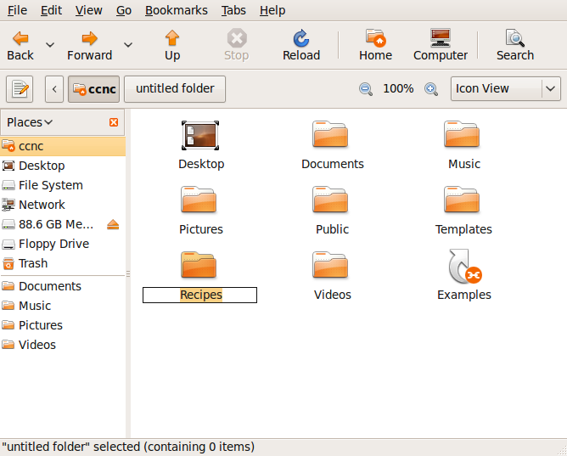
You could, if you wish, create sub-directories and create another level of sub-directories within each. First work out a meaningful directory structure for your own needs, and then create this structure using the method that has just been described.
To delete a directory, click on the directory name or icon and press the Delete key on your keyboard.

Renaming directories
Extension | Example | Description
sxw | jamaica.sxw | A Writer text file
sxc | populationSA.sxc | A Calc spreadsheet file
stw | invoice.stw | A template file that can be used as the basis for creating Writer text files
sxi | client.sxi | An Impress presentation
pdf | contract.pdf | A picture document format file. This format allows a file to be sent in a format that can only be read and not edited. To read such a file you would need a pdf reader
htm, html | index.htm | Htm and html files are files that can be read using a web browser
txt | notes.txt | A text file containing pure text without any formatting
rtf | plans.rtf | A rich text format file. This is a format that can be used for exchanging files between different types of system
doc, docx | jamaica.doc | A Microsoft Word document file
xls, xlsx | populationSA.xls | A Microsoft Excel spreadsheet file
ppt, pptx | client.ppt | A Microsoft PowerPoint file
pps, ppsx | client.pps | A Microsoft PowerPoint presentation file
mdb | vendors.mdb | A Microsoft Access database file
zip | install.zip | A compressed file in zip format
gz | install.gz | A compressed file in gzip format
tar | oo-137.i586.tar | A tarball file .tar files are used for creating installation packages
png | sky.png | A common format for storing graphic images
jpg, jpeg | sky.jpg | A common format for storing graphic images
tif | sky.tif | A common format for storing graphic images
gif | sky.gif | A common format for storing graphic images
Extension | Example | Description
wav | trumpet.wav | An audio file
au | trumpet.au | An audio file
mpg | concert.mpg | A video file
avi | concert.avi | A video file
tmp | ws0001.tmp | A temporary file
You can rename a directory by clicking on the icon or name of the directory and clicking on Edit->Rename. Then simply type the new name in the name field.

Copying, Pasting and Moving Directories
To move a directory to another place:
- Click on the directory name or icon and hold down the left mouse button while you drag it to the new location.
or
- Click on the directory name or icon, then choose Edit>Cut from the menu.
- Go to the location you want to place the directory and the click on Edit->Paste from the menu.
To copy a directory:
- Click on the directory name or icon, then choose Edit>Copy from the menu.
- Go to the location you want to place the directory and the click on Edit->Paste from the menu.

Working with Files
Files can be recognised by the extension on the file name. This is the part of the file name that follows the final period. The following table illustrates some common file names and examples of each.
File extensions are a Microsoft concept and are not actually needed in Linux. They are however useful in providing information for users about the contents or format of files.

Change folder and file permissions
By default, other users can’t access the files in your home directory. As the owner of these directories and files, you can change the permissions so that other users can access them.
You can set permissions for three categories of users:
- owner: The user that created the file or folder
- group: A group of users to which the owner belongs
- others: All other users not already included
For each category of user, different permissions can be set. These behave differently for files and folders, as follows:
- read: Files can be opened, Directory contents can be displayed
- write: Files can be edited or deleted, Directory contents can be modified
- execute: Executable files can be run as a program, Directories can be entered

Change permissions on a directory
In this example, you will change the permission on the Public directory of your Home folder to allow other users to access these files.
- Open your Home folder (click on Places>Home Folder)
- Click on the Public directory and choose File>Properties
- Click on the Permissions tab
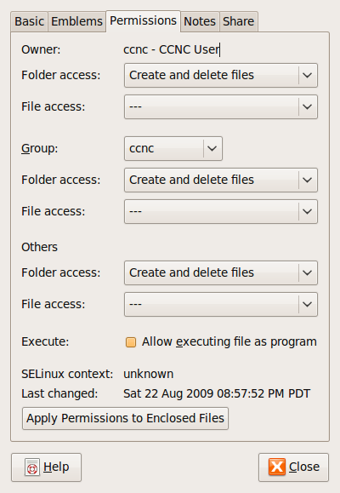
- Change the permissions for Owner, Group and Others to Create and delete files.
- Click the Share tab.
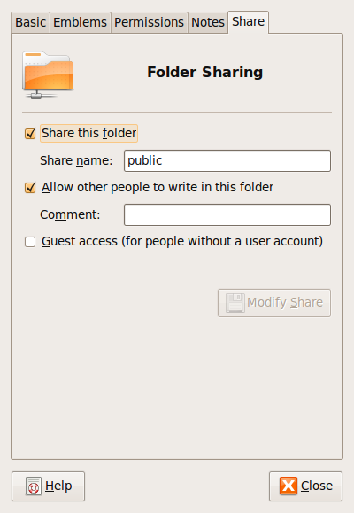
- Check the boxes Share this folder and allow other people to write in this folder.

Change permissions on a file
By default, Linux locks access to files so that they cannot be changed by anyone other than the owner or members of the group.
- Open Nautilus and locate the file whose permissions you wish to view or change.
- Click on the file and select File>Properties from the menu.
- Click the Permissions tab. The current permissions will be checked.
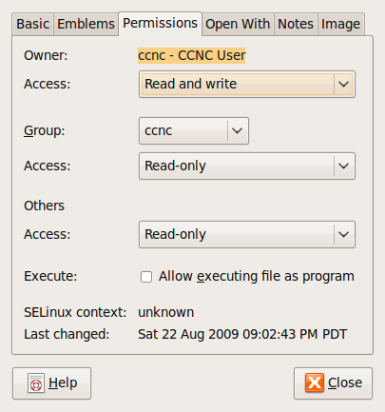
- Change the permissions as desired.

Sort files by name, size, type, date modified
Files can be sorted by name, type, size and date by clicking on the titles at the top of the pane.
- Open the Nautilus file browser and access the directory you wish to sort.
- Switch to List view.
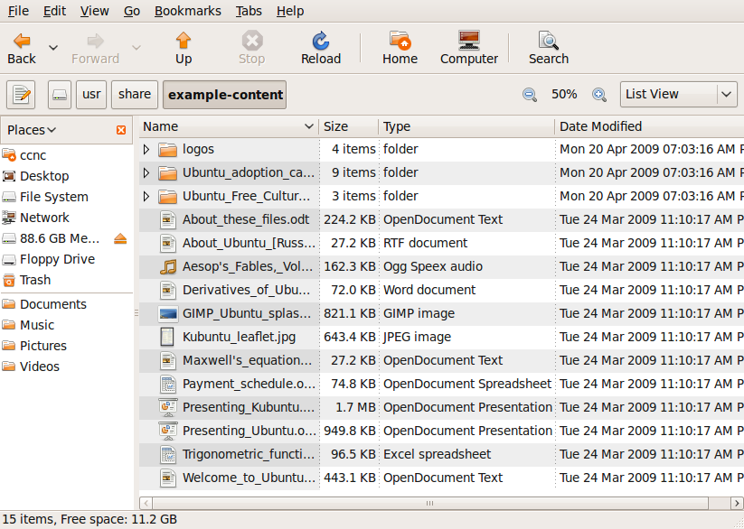
- Click on Name. This will sort the files in ascending alphabetic order by name.
- Click on Name a second time. This will now sort the files in descending order of name.
When you sort files, the directories will appear ahead of the files. Directories and files will be sorted separately.
- Click Date Modified: This will sort the files in date order starting with the most recent.
- Click Date Modified a second time: This will now sort them with the oldest appearing first.
- Click Size: This will sort the files in order of size with the largest at the top.
- Click Size a second time: This will sort them in the reverse order of size.
- Click Type: This will sort the files alphabetically by type.
- Click Type a second time: This will sort them by type in the reverse order.

Copying, Pasting, Moving and Deleting Files

To move a file to another place:
- Click on the file name or icon and hold down the left mouse button while you drag it to the new location.
or
- Click on the file name or icon, then choose Edit>Cut from the menu.
- Go to the location you want to place the file and the click on Edit>Paste from the menu.
To copy a file:
- Click on the file name or icon, then choose Edit>Copy from the menu.
- Go to the location you want to place the file and the click on Edit->Paste from the menu.

Renaming Files
You can rename a file by clicking on the icon or name of the file and clicking on Edit>Rename. Then simply type the new name in the name field.
Note: The part of a file name following the final period (full stop) is called the file extension. This often has a special significance which will be lost if it is changed. For example, the system will recognise that a file having a pdf extension can be opened with a pdf reader or that a file with a png extension is a graphic image.
If you do change a file name, only change the part that is to the left of the first period.

Importance of Backups
There are many things that can cause loss of files. These include:
- Mechanical failure of a hard drive.
- Damage to the system due to natural disasters such as fire, floods and earth movement.
- Theft of the system.
- Corruption of data due to computer viruses.
- Deliberate corruption or deletion of data through criminal activity.
In order to protect data, it is important that copies of important files are made and kept in a separate location so that if loss occurs to the main system, data can be recovered from the copies. Copies of important files are referred to as backups.

Deleting and Restoring Files
When you delete files or directories in Ubuntu, by default the files are moved to the trash bin where they wait until the trash is emptied. This means that if you delete files by mistake, you can restore them from the trash bin. However, once you empty the trash those files can no longer be easily restored, so be careful when you are deleting items.

Delete files, directories/folders to the trash bin
- Select (highlight) the files you wish to delete.
- Do any one of the following:
  - press the Delete key
  - drag the file to the trash bin
  - choose Edit>Move to Trash from the menu.

Restore files, directories/folders from the recycle bin/wastebasket/trash
- Double click on the Trash icon on the desktop OR open your home folder by choosing Places>Home Folder. From there navigate to Trash.
- Select the files you wish to restore.
- Choose Edit>Restore. The files are then restored to the folder from which they were deleted.

Empty the recycle bin
With time Trash will accumulate hundreds of files. Rather than waste space, empty Trash on a regular basis.
- Double click on the Trash icon on the desktop OR open your home folder by choosing Places>Home Folder. From there navigate to Trash.
- Choose File> Empty Trash from the menu.

Searching for files and folders
The first step to keeping track of your files and directories is to create a logical set of directories that works for you. When you are having trouble locating a file or directory, however, Ubuntu has a search utility that can help.

Find Files
- Choose Places>Search for Files from the desktop menu.
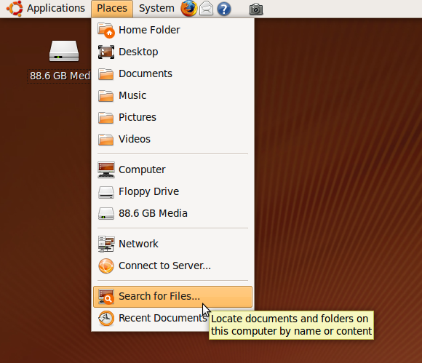
- In the Name contains field, type in the name of the file.
- Choose a directory to search in from the Look in folder field.
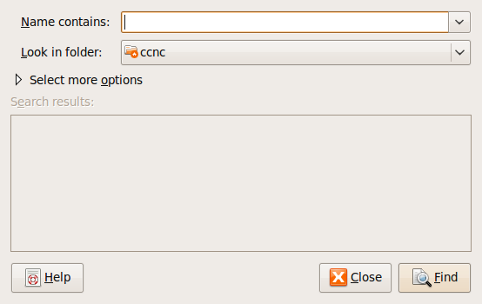
- Click on the Find button. Your search results will appear in a new window. If your file is in the results, you can double-click on it to open.
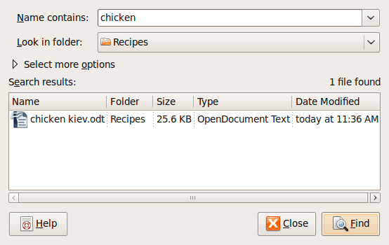

Note: In searching for files, the wildcard character, *, plays a very useful role. * represents any number of characters.
For example:
doc* means any file with a name beginning with the letters doc
*doc means any file with a name ending with the letters doc
*doc* means any file containing the letters doc in its name

Search for files by content, date modified, date created, size, wildcards
You can narrow your search by specifying other search options such as when the file was modified, who the owner of the file is, what the file size is and what text is contained in the file. You can also use a combination of the other options.
Expand the Select more options field and choose the options you want from the drop-down menu. You will then be prompted for information regarding the option you chose.
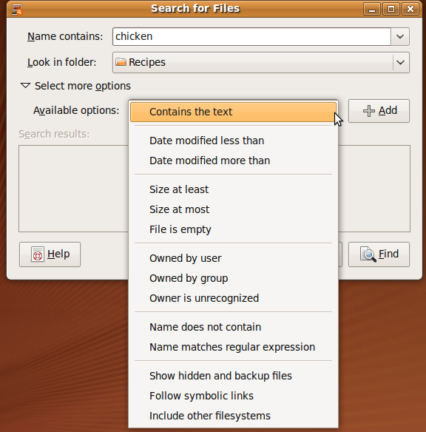

Compressing Files
Each file has a size associated with it. Roughly speaking the amount of space a file occupies of disk is about the same as its file size (in reality, it takes up somewhat more space than this). When files are stored on a CD or transmitted across the Internet, it is important to know the amount of disk space they occupy. Special algorithms (methods) have been developed to compress files into smaller sizes.
File compression is a way that a number of files can be compressed into a single file or a single file can be compressed to take up less space on a hard drive or other medium. For a compressed file to be usable, it must first be decompressed.
There are numerous utilities that enable you to work with compressed files. The next example will illustrate the use of Archive Manager, an open source compression utility for Ubuntu.

Compressed archive formats
The following formats are installed by default with Ubuntu. There are other types of archives in use, but they require additional software to be installed on your system.
Format | File extension | Note
tar | .tar
gzip | .tar.gz, .tgz, .gz | Compressed .tar or compressed single file
bzip | .tar.bz, .tbz, .bz | Compressed .tar or compressed single file
bzip2 | .tar.bz2, .tbz2, .bz2 | Compressed .tar or compressed single file
lzma | .tar.lzma, .lzma | Compressed .tar or compressed single file
zip | .zip | Common format used in Microsoft Windows systems
jar | .jar, .ear, .war
CD images | .iso | Read-only

Compress files in a folder on a drive
- Using Nautilus, open the directory with the files you want to compress.
- Select (highlight) the files which you want to compress.
- Choose Edit>Create Archive to open the Archive Manager utility.
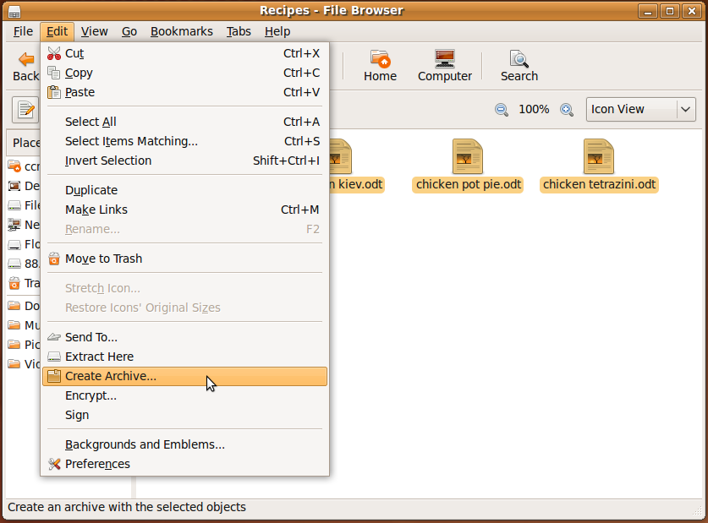
- In Archive Manager, type in a name for the archive and then choose the type of archive you want to create.
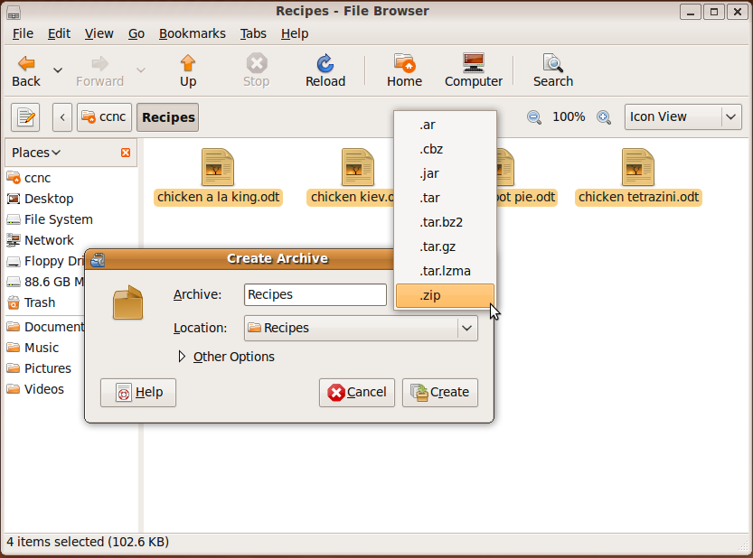

- Click on the Create button. The compressed file will be saved in the same folder.
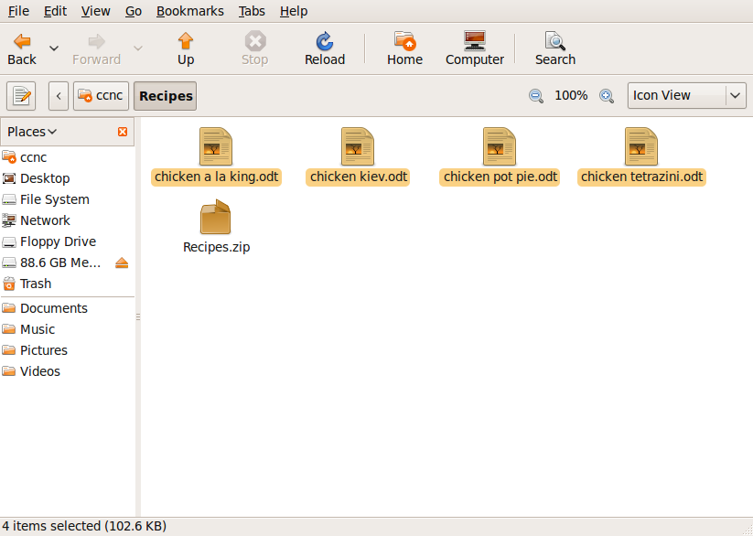

Extract compressed files from a location on a drive
- Using Nautilus, open the directory with the compressed archive you want to extract.
- Select (highlight) the archive which you want to extract.
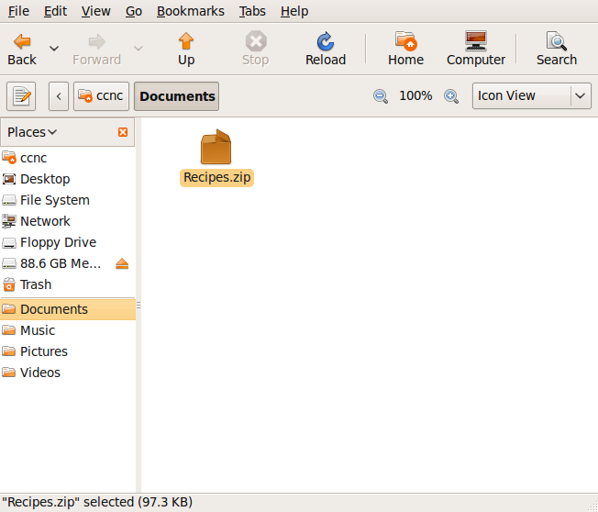

- Choose Edit>Extract Here to open the Archive Manager utility.
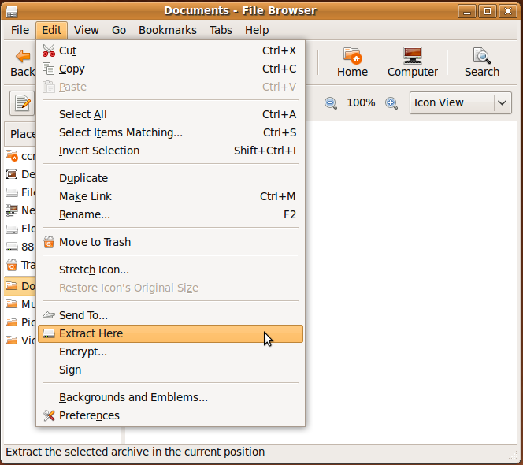
- The archive will be extracted to the same folder, creating a subdirectory with the archive name. This subdirectory will contain the extracted files.
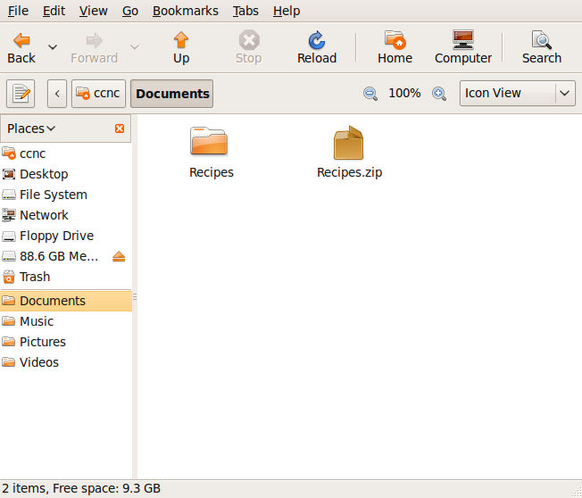

Summary
In this section, you learned:
- the concept of directories and files as they apply to the Linux operating system
- how to use the Nautilus File Browser to:
  - navigate through directories
  - change the view options for directories
  - create, rename, move, copy and delete directories
  - change permissions for directories
- how files are named and what filename extensions are
- how to use the Nautilus File Browser to:
  - sort files by name, size and date modified
  - create, rename, move, copy and delete files
- the importance of backing up data
- How to use the Trash Bin
- How to search for files and directories
- How to use a file compression utility

Ubuntu Utilities

Section overview
Utilities are programs that are included with the operating system. They are installed with the operating system, but are in fact application software. They can be very helpful, as they perform important tasks but tend to use very little of your system’s resources.
You have already been introduced to the file compression utility, Archive Manager, in the previous section. In this section, you will use utilities for capturing images of your computer screen and for editing text files.
After studying this section you will be able to:
- Use the Print Screen utility to take screenshots or images of your computer screen.
- Use the Text Editor utility as a simple word processing application for editing text files.

Print Screen
Print screen takes a snapshot of your desktop and saves it as an image, which you can then use in documents.
- Press the Print Screen button on the keyboard (it may be abbreviated to Prt Scr or similar). This activates an application which captures an image of your screen.
- Choose whether to capture the whole screen, the active window or a portion of the screen.
- If you would like a few seconds to get the screen ready before capture, set the delay time.
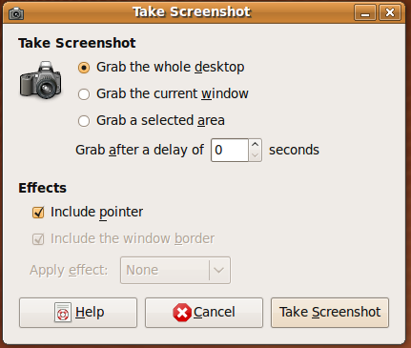

- Click the Take Screenshot button.
- Specify a name and location in which to save the snapshot and click on the Save button.
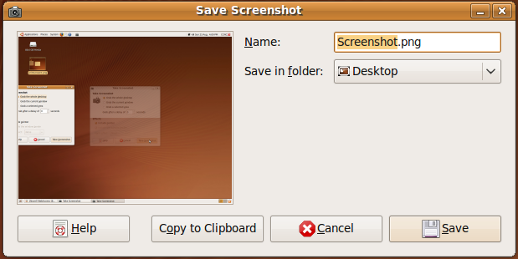
The snapshot will be saved in .png format, which can be opened with most standard graphics programs.
The image can then be inserted into a document, edited with a graphics program or sent by email.

Text Editing
Text editing is an application that allows you to create text documents. It is a simple word processor application and although it doesn’t have the features of an advanced word processing program like OpenOffice Writer, it can be very helpful.

Start Text Editor
- Click on Applications from the desktop menu
- Go to Accessories
- Click on Text Editor
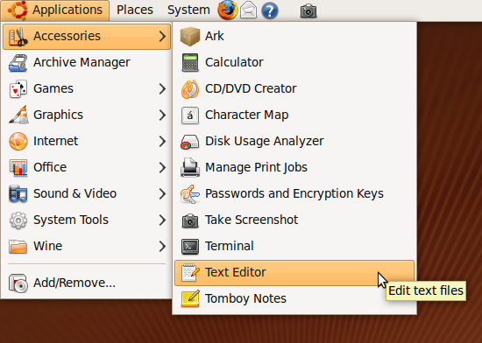
The components of the screen are shown below.
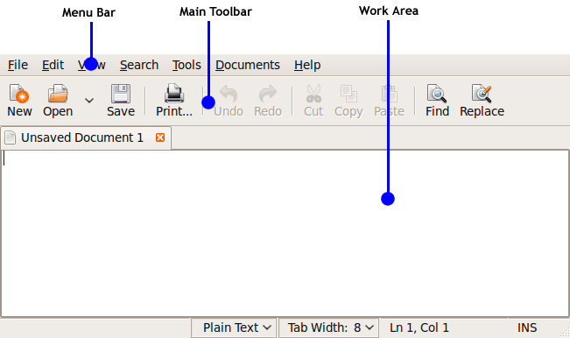

Close Text Editor
- Choose File>Quit from the text editor menu.
This will close all open documents and exit Text Editor. If you have made any modifications to open documents, Text Editor will remind you that the document has not been saved and ask you whether you wish to save or keep it. It will also give you the option of cancelling the Quit operation.
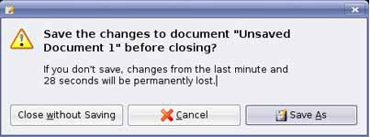

Open a file
One of the advantages that text editors provide for us is the facility to save our work and recall it at a later time. We can then print our work or make further changes (edit). In addition, we are able to create many versions of the same document, each of which can be saved on our hard drive under an appropriate name.
To open a document:
- Choose File>Open from the Text Editor menu
OR
Click on the Open button in the Text Editor tool bar.
The Open dialogue will appear. In general, this will point to your home directory.
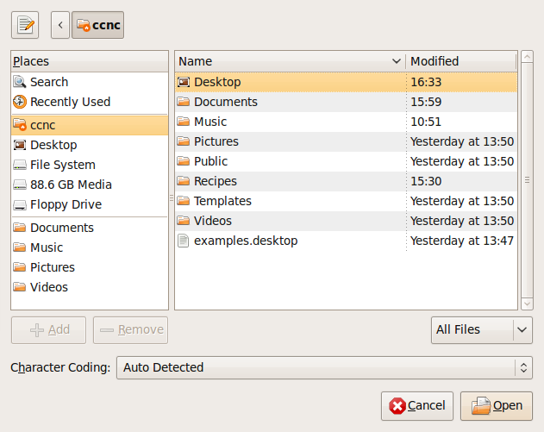

- If necessary, navigate to the desired directory.
- Highlight the file you wish to open.
- Click Open.

Create a new document
A new document is created for you each time you open Text Editor.
To create a new document from within Text Editor:
- Choose File>New from the Text Editor menu. This will display a blank screen in which you can create a document.
- Using your keyboard, type the text for the document. Use the <Enter> or <Return> key on your keyboard to start a new paragraph.

Save your document
When you work with a document on your computer, the working form resides in the computer's RAM. Remember from Module 1, this is temporary memory used for your current activities. Since RAM is volatile, when the computer is switched off, everything that is in RAM is automatically lost. In order to keep your work you will need to save your documents before you shut off your computer.
When you save a document, you give it a name and you specify where it is to be stored.
If you have opened a document and made some changes, the process of saving it is very simple:
- Choose File>Save from the Text Editor menu.
This will change the contents of the stored version so that it is identical to the version that is displayed on your screen. In this case, the previous version on disk is overwritten. If you use File>Save in a newly created document, Text Editor will automatically assume that you wish to use File/Save as.

Saving a new document
When you create a document from scratch, there is no version stored on disk. To save the file to disk:
- Choose File>Save as from the Text Editor menu.
The Save as dialogue will appear. In general, this will point to your home directory.
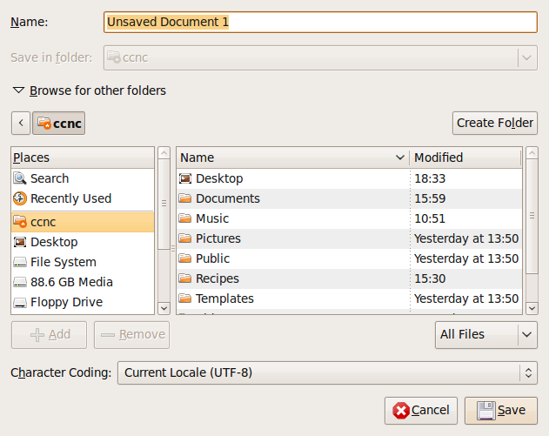
- If necessary, navigate to the directory in which you wish to save the file.
- Enter a name into the Name window.
- Click Save.

Summary
In this section, you learned:
- How to use the Print Screen utility to take screenshots or images of your computer screen.
- How to use the Text Editor utility as a simple word processing application for editing text files.

Print Management

Section overview
Remember from Module 1, you should avoid printing documents unless it is necessary because of the impact on the environment and since it is quite possible to do much of your reading on-screen.
However, you may want to print documents to read when you can’t be near a computer, for handouts for meetings or presentations or even your photographs.
After studying this section you will be able to:
- Set up a printer in Ubuntu.
- Print documents from an application such as Text Editor.
- Monitor your print jobs.
- Pause, resume or cancel print jobs.

Printer Setup

Adding a Printer
- Open System>Administration>Printing from the desktop menu.
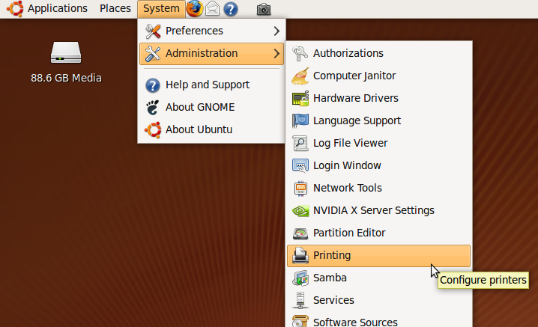

- The printer configuration utility will open. Double click the New icon to add a new printer.
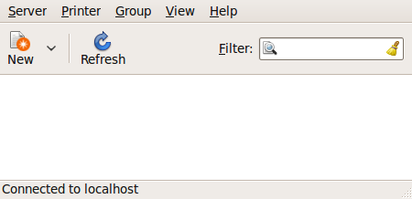
- The printer configuration utility will then look for connected printers and printer ports. Select the printer you want to install and click on the Forward button.
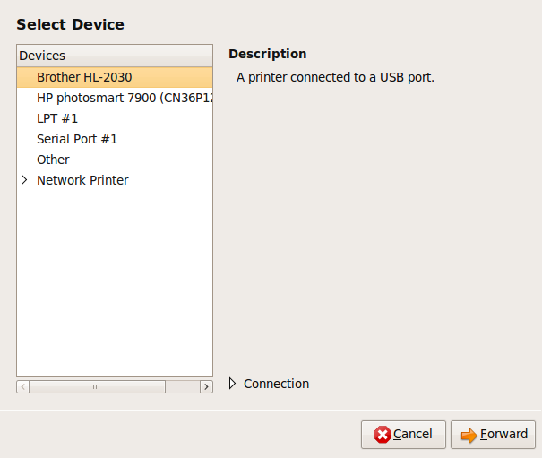

- The printer configuration utility will search for the proper printer drivers (software) for your printer. It may find the drivers and install them automatically or it may ask you to select the printer.
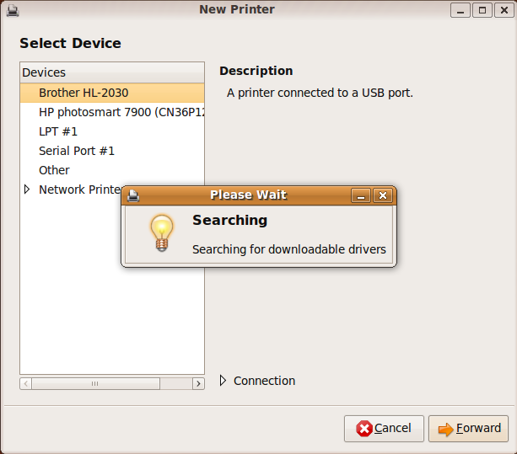
- Select the model of printer and click on the Forward button.
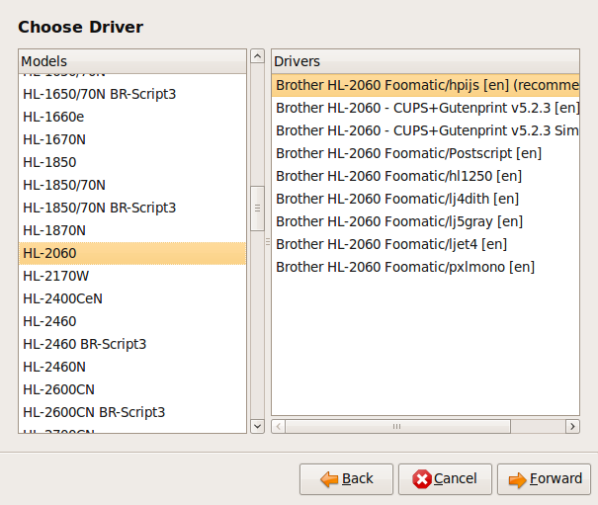

- Apply the changes and your printer is set up.
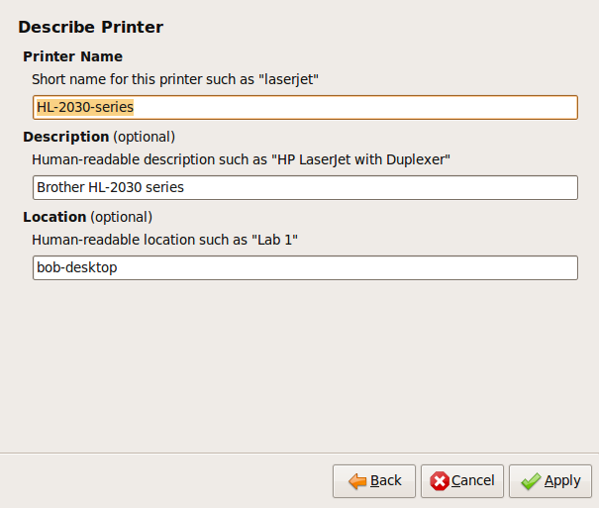
- Print a test page to test your printer settings.
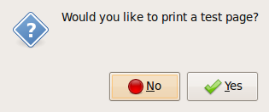

Note: Suppose you have more than one printer available. The default printer is the printer that will automatically be offered to you when you wish to print. Other printers have to be specifically selected.

Print Outputs

Print a document from a text editing application
- To print from Text Editor, first open the document you want printed. Then click on File>Print from the Text Editor window.

- Select a printer from the Print dialog box that opens. Choose which pages you wish to print and the number of copies, and then click the Print button.
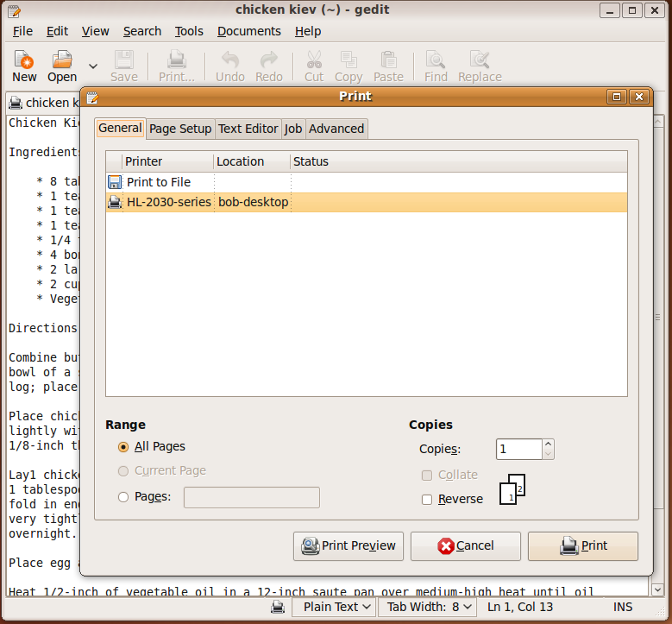
- Adjust Print range and Copies, if necessary.
- Click OK.

View a print job’s progress using a desktop print manager
Print manager is a utility that lets you view the print jobs in progress and to cancel or pause them if necessary. To open the print manager:
- Open System>Administration>Printing from the desktop menu.

- Click on the printer you sent the print job to and then .choose Printer> View Print Queue from the menu.
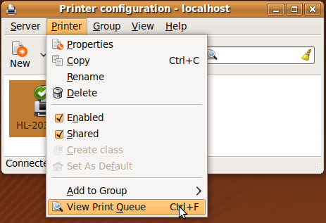
- When the Print Queue opens, you can see the print jobs in process.
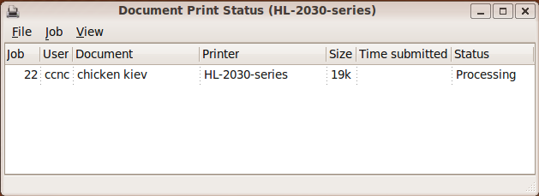
- You can manage the print job by choosing Job from the menu and clicking on the appropriate choice:
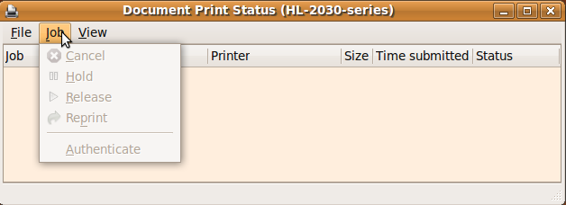
  - Cancel will cancel the print job in progress
  - Hold will pause the print job in progress
  - Release will resume a print job that is being held
  - Reprint will start the print job from the beginning

Summary
In this section, you learned how to:
- Set up a printer in Ubuntu.
- Print documents from an application such as Text Editor.
- Monitor your print jobs.
- Pause, resume or cancel print jobs.

Module summary
In this unit you learned:
- The main features of the Ubuntu operating system including how to adjust the main computer settings and use built-in help features.
- How to operate effectively around the computer desktop and work effectively in the GNOME graphical user environment.
- The main concepts of file management and how to efficiently organise files and folders so that they are easy to identify and find.
- How to use utility software to compress and extract large files.
- How to use simple text editing and print tools available within the operating system.
- How to set up and monitor a printer in Ubuntu.

